**link for dataset** : https://zenodo.org/record/5120960#.ZAs3vnZBy3B

This dataset of breast cancer patients was obtained from the 2017 November update of the SEER Program of the NCI, which provides information on population-based cancer statistics. The dataset involved female patients with infiltrating duct and lobular carcinoma breast cancer (SEER primary cites recode NOS histology codes 8522/3) diagnosed in 2006-2010. Patients with unknown tumour size, examined regional LNs, positive regional LNs, and patients whose survival months were less than 1 month were excluded; thus, 4024 patients were ultimately included.

**SEER Program of the NCI** : NCI's Surveillance, Epidemiology, and End Results (SEER) program provides information on cancer statistics that underpins efforts to reduce the cancer burden among the U.S. population.

**Infiltrating ductal carcinoma** : Invasive ductal carcinoma (IDC), also known as infiltrating ductal carcinoma, is a type of breast cancer that starts in the milk ducts of the breast and moves into nearby tissue. In time, IDC may spread (metastasize) through the lymph nodes or bloodstream to other areas of the body.

**lobular carcinoma** : Invasive lobular carcinoma (ILC) is breast cancer that begins in one of the glands that make milk, called lobules, and spreads to other parts of the breast. It’s the second most common form of breast cancer after invasive ductal carcinoma, which begins in a milk duct.

**tumour size** : The longest length of the tumor in the tissue removed during surgery is reported as the tumor size. Tumor size may be measured under a microscope, especially for small tumors. Tumor size is strongly related to prognosis

**prognosis** : "knowledge beforehand" of how a situation is likely to turn out.

**Lymph node** : A small bean-shaped structure that is part of the body's immune system.

**Regional Ln (lymph node )** : A negative SLNB result suggests that cancer has not yet spread to nearby lymph nodes or other organs. A positive SLNB result indicates that cancer is present in the sentinel lymph node and that it may have spread to other nearby lymph nodes (called regional lymph nodes) and, possibly, other organs.

Immune system : the organs and processes of the body that provide resistance to infection and toxins. Organs include the thymus, bone marrow, and lymph nodes.

You have hundreds of lymph nodes throughout your body. Your lymph nodes are part of your lymphatic system, which, in turn, is part of your immune system.

Lymph nodes are little bean-shaped structures that contain immune cells that help fight infection. They’re connected by a system of lymph vessels that carry fluid throughout your body. As fluid passes through your lymph nodes, they filter out harmful substances.

Cancer spreads when cancer cells break away from the primary tumor. In breast cancer, these cells are most likely to reach the [lymph nodes](https://www.healthline.com/health/what-happens-when-cancer-spreads-to-the-lymph-nodes) closest to the affected breast.

Usually, these lymph nodes are under the arm, but there are also clusters of lymph nodes near the collarbone and breastbone.

The ones that are closest to your breast are called sentinel lymph nodes. The nodes under your armpit are called [axillary lymph nodes](https://www.healthline.com/human-body-maps/axillary-lymph-nodes#1).

A term used to describe cancer that has spread (metastasized) from the place where it first started to another part of the body. Secondary tumors are the same type of cancer as the original (primary) cancer.

Primary cancer is defined as the original site (organ or tissue) where cancer began

**Steps of cancer :**

Stage I: The cancer is localized to a small area and hasn't spread to lymph nodes or other tissues.

Stage II: The cancer has grown, but it hasn't spread.

Stage III: The cancer has grown larger and has possibly spread to lymph nodes or other tissues.

Stage IV: The cancer has spread to other organs or areas of your body

A term used to describe the original, or first, tumor in the body. Cancer cells from a primary tumor may spread to other parts of the body and form new, or secondary, tumors. This is called metastasis. These secondary tumors are the same type of cancer as the primary tumor.

Cancer is a disease caused when cells divide uncontrollably and spread into surrounding tissues. Cancer is caused by changes to DNA. Most cancer-causing DNA changes occur in sections of DNA called genes. These changes are also called genetic changes

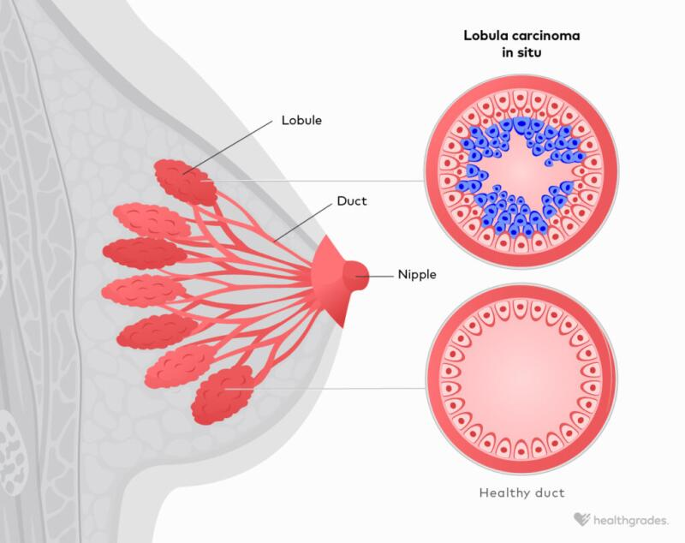

Image link : <https://www.healthgrades.com/right-care/breast-cancer/lobular-carcinoma>

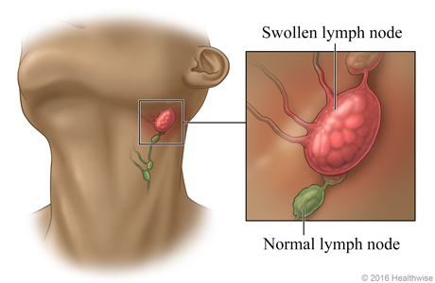

Image link : <https://www.nyp.org/healthlibrary/multimedia/swollen-lymph-nodes-swollen-glands>